Week one: Practical Exercise one

Setting up tools

**Folder**

Create a new folder on your desktop and name it ‘Girl Geeks website’. We will be using this folder to save our work for the duration of the course, so make sure you don’t delete it!

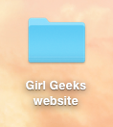

**Browser**

Open your usual browser, go to <http://www.google.com/chrome/> and click the download now button.

If you already have Google Chrome installed, go to the Chrome menu and select Chrome > About Google Chrome. This will let you know if your browser is the latest version or if you will need to update it.

**Text Editor**

**Creating a web page on a PC**

To create your first web page on a PC, start up Notepad. You can find this by going to:

Start > All Programs > Accessories > Notepad

**Creating a web page on a MAC**

To create your first web page on a Mac, start up TextEdit. This should be in your Applications folder.

Unlike Notepad, TextEdit works as a rich text editor by default, which means we can work with fonts, make text bold and italic, and so on. However, we want to work with TextEdit as a plain text editor, so you’ll need to adjust some of the TextEdit preferences.

Start TextEdit, and then select TextEdit > Preferences from the menu to bring up the Preferences screen. Select Plain text within the New Document Attributes.

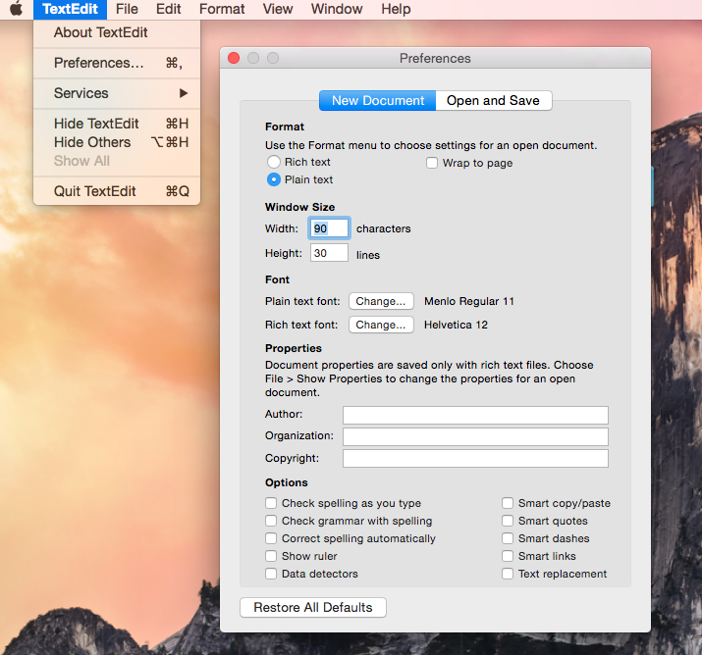

Select the Open and Save tab, tick Display HTML files as HTML code instead of formatted text. Untick Add “.txt” extension to plain text files.

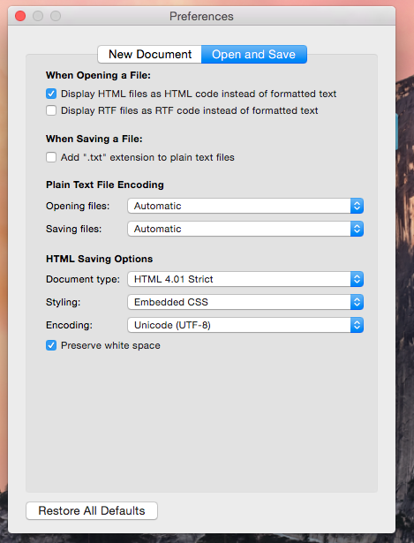

Then close the Preferences screen. The next time you create a new file in TextEdit, it will be a plain text document.

Once we have set this up, we are ready to start building your first website!